**Sprint planning 4**

AutoMate

Before we start with our sprint planning for the next sprint, we must give some context over some changes that have been made to our project. The first system that we produced was the “Automated greenhouse system. While this system had a lot of potential to prosper, it could sadly not be completed within the scope of our project. By this we mean that the greenhouse system would work in perfect conditions if it was a centralized system, yet this was not the assignment. Therefore, we came up with a new system that was developed while keeping the occupancy management system in mind.

**The smart parking system**

In short, the smart parking system will keep count of how many parking spaces are occupied and how many cars are inside the parking facility. With this knowledge we can determine if there are any parking spaces left.

*Our goal is to simplify the parking experience for the user as well as the maintainer.*

The entire design and scope of the system is explained in the system analysis document.

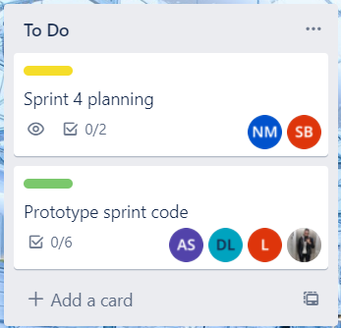

Above you see our Trello sprint board and there we include our planning. Our main goal for Sprint 3 was to structure our code and have all sensors working. For this sprint we have made an entirely new analysis document including multiple designs. Therefore, we were not able to have all sensors up and running. We were successful in developing a class design that was reviewed and approved by Sioux.

Our main goal for Sprint 4 is to implement further feedback we got from Sioux and we want to have our communication class fully Object Oriented. We are still in doubt about if our communication protocol will need a king device. This means that one device can send and receive data and that one device can be claimed as the root by checking which module has the lowest IP. Another idea we got from Sioux is that every module will send their data to the Node-Red application and the dashboard will determine which module it has to listen to, depending on which one has the lowest IP.  
A side goal is to have multiple sensors working so we can have a nice demo in the while presenting our next sprint.

These tasks refer to Use Case ID: 001 “Identify available parking spots” in our Analysis document.